**Develop a prototype considering fitness for purpose in the broadest sense involves:**

* Considering the context when determining the suitability of materials and/or components, and of practical techniques and processes
* Selecting suitable materials and/or components; tools and equipment; and applying techniques and processes to make the prototype
* Using results from testing and stakeholder feedback to inform the making and trialling of the prototype
* Prototyping to gain specific evidence of fitness for purpose
* Explaining any decisions to accept and/or modify the prototype based on a judgement against the brief.
* Evaluating the way the combination of selected materials and/or components and practical techniques and processes work together to ensure their effectiveness in making a prototype.
* Synthesising evidence from ongoing testing (included prototyping) and stakeholder feedback to optimise the prototype and justify the prototype’s fitness for purpose against the brief.

# **Task**

Recommender systems are most commonly recognised as playlist generators for video and music services like Netflix, YouTube and Spotify, product recommenders for services such as Amazon, or content recommenders for social media platforms such as Facebook and Twitter.

“In October, 2006 Netflix released a dataset containing 100 million anonymous movie ratings and challenged the data mining, machine learning and computer science communities to develop systems that could beat the accuracy of its recommendation system, Cinematch (Bennett & Lanning, 2007).

Given a dataset of movies, users and their ratings, you are to create a recommender system.

You must:

* Search for a movie
* Rate a movie
* Recommend a movie specific to the user based on their rating
* Have a GUI
* Use persistent storage (i.e. store the data in a file)

# **Set Up**

## **Stakeholders and Intended Environment**

My Movie Recommendation System program is aimed at movie watchers to be able to rate movies they’ve watched and be recommended movies based on their ratings. My stakeholders will be:

* Onslow teacher (Mr Ny)
* Class peers
* Younger sister (Watches a lot of movies)

My program will be intended to be used at people’s homes when they’re trying to find a good movie to watch. They will be able to run the program sitting on their couch, rate movies, and get recommended movies based on previous rating of other movies. It will be useable by all ages with a movie database full of movies of all age ratings.

## **Language Research**

**Scratch**

Scratch is a very basic form of programming used to teach beginners how to program. This means it would quick and simple to use, and I could output a high quality program, which would be simple to make. It also is visually pleasing as it has graphical animations which make it a good language option for a game aimed at kids. Though I need to make my own GUI, and will be using an AI trainer which scratch would not have the tools to accomplish this.

**Java**

Java is a programming language that produces software for multiple platforms. It has the advantage of being very universal, it was also designed to be easy to use, write and debug. The disadvantage of this language is that Java has its own structure and syntax rules, so it would require learning a new language to use this programing language, which would have a lower quality outcome.

**Python**

Python is a user friendly programming language which is simple to understand and has many possibilities on what it can code. I understand how to use python so I would be able to produce a high quality program using that language. I can also produce my GUI using python, and the AI training algorithm I’m using will be in the python language. Python also has many added tools like tkinter which are essential for a GUI.

## **IDE Research**

**Pycharm**

Pycharm is a text code editor which is usable for coding Python, JavaScript, CSS, and many other programming languages. It is easy to debug due to syntax highlighting, and error highlighting. It has automatic formatting making code easier to read and to write. I have never used Pycharm so I would need to learn how to use a new editor and it is not downloaded on the school computers, which is what I will be using to write my program on.

**Repl.it**

Repl.it is an online python editor. This has the benefits of being accessible anywhere with internet access making it useful to work out outside of class. Though it is not completely free to use and I cannot always ensure that I will have internet access, and be able to work on my program. Repl.it also has a large online python library, but it does not contain a GUI. Having a GUI is a major part of my program, and the program would be severely lacking without one.

**IDLE**

IDLE is the main editor python is coded on. It has useful syntax error highlighting, and function colouring making formatting simple and appealing. It can be used wirelessly and the file size is small, so it’s easy to upload to the cloud so I can work on it at home and at school. It is also already installed on the school computers and what I use to program and school and at home.

## **Prototyping Methods Research**

**Storyboarding**

Story boarding is a form of prototyping used to help visualise a prototype and follow the steps within a program. As I am using a GUI, storyboarding will be very useful for planning how my GUI interface will be presented to the user, meaning I won’t need to program it all to see how my program will appear to the user. Though it will no assist me with producing my program, and will not be able to give my stakeholders a useable outcome to test, only a visual one.

**Rapid Prototyping**

Rapid prototyping is a fast method of prototyping which builds on stakeholder feedback by making a prototype, getting feedback, making the changes based on the feedback, then getting it reviewed again. This process is repeated until a final product has been made. This will be my main method of prototyping as it fits my program type and allows me get and build on feedback quickly.

**Wizard of Oz Prototyping**

Wizard of Oz Prototyping works by designing a fake functioning version of your prototype which doesn’t use up resources but the stakeholder can give feedback on. I may use aspects of this form of prototyping, by writing simple code to complete tasks which I can then present to my stakeholders. Though my program is not quite large enough or resource intensive for this method to be valuable as a main prototyping method.

**Agile**

Agile is a methodology for approaching a task in a flexible manner so many changes can be made through out the process. This can be really beneficial when approaching a project with only a brief concept and when finding out if a project is doable. The process is very responsive to change, especially when the tasks needed for the product change priority often. It requires little organisation and set up for the team to get started, which means production can start quickly. This method is very useful for this task, as I will be getting lots of stakeholder feedback through the project, so what task I need to do will be constantly changing. One way this is done is by using a Kanban board.

## **Equipment Research**

**Tablet/iPad**

Tablets are touch screen devices which can run various programs. They lack adaptability as they don’t have the capacity to run the same programs I would typically run on a computer to make my program. Programs such as Python IDLE and Microsoft Word. Though these are available to run on a tablets the functionality of the applications is much worse than on a computer. Tablets also struggle to multitask as they lack the ability to work on multiple tabs at once and are slower to load things. This is why I will not be using a tablet or iPad for my prototyping assignment.

**Computer**

Computers are electronic devices which can be used for storing and processing data, and running complex programs. I will be able to use Python IDLE and Microsoft Word on a computer. Computers also have a keyboard and mouse attached which speeds up the usage of a computer and applications. This makes them more time efficient than a tablet and computers also have a greater processing ability. This is why I have chosen to use a computer with a keyboard and mouse attachment for making my program.

## **Tool Research**

**Google Docs**

Google Docs is an online word processor where a user can work on word documents which are then saved automatically to the cloud and can be accessed anywhere. This can be very useful and work isn’t lost as it updates saves as you work. Though google docs has limited functions and does not have the ability to make headers (for navigation), make footnote references, and inserting images can be a hassle.

**Microsoft Word**

Microsoft Word is a word processor application. It is very versatile and adaptable with lots of tools such as navigation headers, easy image inserting, auto updating bibliography, and many formatting options. It can also be exported in multiple formats making it very useful for submitting my assessment, and uploading it to One Note.

**One Note**

One Note is a computer program for free-form information gathering. Users are able to upload file, texts and images onto a page in any order with no strict formatting. The benefits of One Note as I can upload .py and .docx files which I can then access and work on at home and at school. One Note is created by Microsoft so it is designed to work in succession with other Microsoft software such as Word. I also can’t lose it, unlike if I were to copy the files onto a usb which is easily misplaced. The disadvantages of One Note is it is easy to accidentally upload an old file over a new file, deleting work.

**Github (Online)**

Github is an online coding version reviewer and manager. It allows the user to upload versions of code to keep track of changes and compare new and old code. It is also easy for other users to review and comment on new code versions. It also has useful tools, such as a project manager which allows the user to make a Kanban board. The coder can also request reviews from other users, which will be very useful for getting my stakeholder feedback. This also allows for all my versions, feedback, and Kanban planning to be stored in one place. (Features, 2019)

**Kanban Board**

Kanban is a method used to implement agile software development. When this method is used it prioritises on the continual delivery of an outcome. The Kanban process is designed to let all members of the team know what each person is working on, where parts of the task are up to, and what needs to be worked on. Though I won’t be working in a team this will be a great method for me to keep track of how much work I have to get done before the deadline. The main feature of the Kanban methodology is the Kanban board. The Kanban board is where the task are visually represented for all team members to see. This is why I have chosen to use a Kanban board in my prototyping. (Rehkopf, n.d.)

## **Research Conclusion**

After researching 3 languages I have chosen to work with python as my main language, due to its added tools for creating GUIs and the AI engine I will be using, python is the best option. From my IDE research I decided I would use IDLE as my language editor, as it works best with my chosen language and allows me to easily work on my task at home and school. It also highlighted how using Repl.it wouldn’t be an option due to its lack of GUI making tools, as having a GUI is a big requirement for this task.

My prototyping methods will be what I show to my stakeholders and get their feedback on and the method I use for producing a product for feedback. I’ve decided I will use some storyboarding but it will not be a main prototyping method as it does not affect how I program my code, only how it is visually represented as a GUI. Wizard of Oz prototyping is less effective in programming projects as it relies on making mock up versions which is difficult to do when programming, as a program either fully works or it doesn’t, so it can be tricky for a stakeholder to give feedback using this method. This means that rapid prototyping will be my main method, as it relies on getting feedback, making changes, and repeating this often. As I have limited time for this task it is the most effective way to produce a product which as be adapted due to stakeholder feedback and improved over time.

I will be approaching this task with an agile method, as my project will be constantly changing and needs to be designed in a way which is adaptable. It will allow me to get constant feedback which I can implement without it requiring me to start again if the feedback were to not fit with my plan. It will also mean that my plan will be constantly changing and the order my tasks will be completed will be changed too. I will be representing my agile planning using a Kanban board.

From my equipment research I concluded that using a computer would be much more effective than a tablet. As I have chosen IDLE as a programming IDE, I am only able to make my program on a computer, as a tablet wouldn’t be able to run the application, and would struggle to process the code produced. Also computers can process things faster and do more complex tasks, so it is much more effective for a computer, mouse and keyboard to be used to make this program.

I will be using many different tools throughout this assessment. For writing my documentation and storing my stakeholder feedback, I will be using Microsoft Word. Word has useful tools for formatting and navigating, which will be very useful for my documentation as it’s quite a large file. I will also use One Note to upload .py and .docx files, so that I can access and work on them at home. Another application I will be using is Github. As I need to show iteration of my program, Github allows me to upload each version of my code and see how each version changes. It also allows my stakeholders to give me feedback on each of these versions. I will also be using Github for making my Kanban board. Using a Kanban board is an agile method of software development which will give me a visual representation of my progress and my tasks while I work on this project. It will also allow me to see when I get stuck on a task for a while and manage my time around each task. It will also prevent me from getting too overloaded with tasks, as I will pull tasks in as I complete them, instead of pushing new tasks in before I’m ready for them.

## **Components**

The programming components which are used in my program are:

* Print Statements
* Functions
* Variables
* Input Statements
* If, Elif, Else Statements
* Import and Export to a file
* Classes and Objects
* GUI

## **Fitness for Purpose**

**Maintenance and Sustainability**

The resources used to make this program are all digital, so they will not produce any waste that could affect the environment or affect future generations negatively. Any paper notes that I take will be recycled at the end of the project. To maintain the functionality of my program through the years I will design the movie database and program in a way that new films released can be added to the file and used in the program. My program should still be able to run and function fully in a few years time, as I don’t think that how python rules work will change into a way where my program won’t function. I will also comment clearly to make sure that anyone else who were to work on my code in the future would be able to understand what I was doing, so that they are able to change parts which may not be suitable in the future.

**Cultural Appropriateness**

When creating this product I need to make sure I consider all individuals who may use it and make sure it fits all different types of people. As I want this program to be used by any type of person, despite age or cultural background, I will make sure to use simple language and visuals which are intuitive to the user. My program will be designed in a way so that little instruction is needed for the user to be able to use it. I will also ensure that nothing within my program could be offensive to anyone, or be misinterpreted. I plan to get my stakeholder feedback from a range of age groups and people of different cultures to ensure my program is inclusive.

**Ethics**

While testing my program I will need to follow ethical guide lines to make sure people with mental or physical disabilities are still able to use my program to its full potential. I will make sure that the visuals of my program are large enough for vision impaired people to read, and that the colours used are simple and not too bright as to not distress autistic users. I will use simple and concise language to keep my program usable by young children or mentally disabled people. While getting stakeholder feedback I will ensure I have permission from my stakeholders to include their names, or not include names if the person wishes not to be named. I will also make sure that any names that I do use will not be shared to anyone outside of this assessment, to ensure security and trust with my stakeholders.

**Legal Requirements**

I avoided copyright problems by writing all of the program and documentation myself, so I didn’t plagiarise anyone else’s work. Any code which was given to me was done so with permission and will be referenced. When doing my research I made sure to reference where I got my information from so my sources were credited.

**Health and Safety**

When working on my prototype I made sure to position myself correctly to prevent damage on my body. One way I did this was keeping a straight back in my chair to avoid back and neck pains. Another way was by looking away from my screen every 15 minutes so that my eyes wouldn’t be strained from the screen light and constant focus. I made sure to be responsible with my equipment and for my environment. I did this by keeping my desk and the space around it clean to avoid tripping. I also made sure to sit in my chair properly to prevent breaking my chair or falling off.

# **Program Outline**

The program will function by training an AI bot with movie ratings given by a user. The user will enter a movie into the search bar, press search, then be given a list showing all titles which contain the search entered. The user can then select a title and give it a rating. The AI will then take the rating into account, compare it to other users who rated the movie the same, and recommend a movie. The search bar and recommendations will come up on the main menu.

The movie data will be in a .csv file written in the format ID, Title, Year, Genre (list). The rating data will be in a separate .csv file written as User ID, Movie ID, rating (ranged 1-5), and timestamp. This will be sorted with 3 classes Movie, Rating and User.

## **Program Plan**

**Part 1**

1. Create Classes
2. Import CSV
3. Build Main Routine
4. Build Similarity Function

**Part 2**

1. Find similar Users
   1. Return movies rated by given user function
   2. Return set of all users who like a movie function
   3. Return set of all users who dislike a movie function
2. Possibility Index
3. Generating Recommendations

**Part 3**

1. Make program run
2. Implement in a GUI

**Part 4**

1. Adapt Engine
2. Improve GUI

## **GUI Plan**

The Lion King

Search

**Recommendations** *appear after user rates*:

**Title**: The Lion King

**Year**: 1994

**Genre**: Adventure, Animation, Children, Drama, Musical

**Rating:**

- **Aladdin**

**- Mulan**

**- Tarzan**

**- Finding Nemo**

**GUI Explained**

The user will search a movie, e.g. The Lion King. After clicking search button, the movie information will appear and give the user the option to rate, up or down arrow. When they give a rating, based on that rating and past ratings 4 movies will be recommended to the user. When a new movie is searched the movie info will all update and rating arrows will appear, the recommended movies will stay and update once the user rates the new movie. They will update based on the past rating and new rating.

## **Rating Data**

I will be getting real people to be my users for my rating data. I will do this by getting them to rate the movies in my list (that they have seen) out of 5. This will create a more realistic chance of a recommended movie being something that a real user would like, as they’re being recommended off of real peoples ratings.

# **Stakeholder Feedback and Development**

## **Engine and Further Development Feedback (06/09/19)**

|  |  |  |
| --- | --- | --- |
| Name | Question | Feedback |
| Josh Keegan  (DTC Class Peer) | - What do you like/ dislike about the concept of the program?  - What do you think would make the program more appealing?  - What do you think would improve the functionality of the program | - I think it is a very good idea because Netflix recommendations can be very unreliable and this is an alternative to getting recommendations.  - A graphic user interface, in which the user can rate movies and display recommendations.  - A larger dataset of users/movies might improve the accuracy of the recommendations. |
| Jacob Galacgac  (Onslow Student) | - What do you like/ dislike about the concept of the program?  - What do you think would make the program more appealing?  - What do you think would improve the functionality of the program | - I think it’s useful to find new movies to watch.  - Having buttons and a more visual program to interact with.  - Having it recommend based on genres to make the recommendation more accurate to the movie rated. |
| Lachlan Alsop  (DTC Class Peer) | - What do you like/ dislike about the concept of the program?  - What do you think would make the program more appealing?  - What do you think would improve the functionality of the program | - I think the program is a great idea but don’t think it can be well executed with such a small number of movies.  - If the user had buttons to press to rate the movie instead of needed to edit the csv file.  - Having a drop down menu to select movies will have less errors than a search bar. |

**Feedback Conclusion**

Based on this feedback I have decided to implement a GUI, as suggested by Josh. This will allow me to have a dropdown menu of movies to select and then buttons to press to rate the movie. It will also make it more attractive and intuitive for the user, as well as live updating the recommendations. I will also increase my number of users in my user data base, and maybe add a larger selection of movies, though I will need to keep the data small enough to ensure the program still functions at a reasonable speed. I will need to write to a csv file to allow the user to rate movies and have the data update.

## **GUI and Further Engine Development Feedback (16/09/19)**

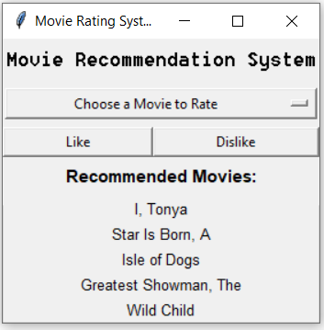I have implemented the GUI as suggested by my previous stakeholders (see right). The GUI lets the current user select a movie from the drop down menu that they haven’t rated yet and removes movies once they’re rated (prevents user from rating a movie more than once) . The recommended movies are then generated and shown below, they update each time the user rates a movie. To develop this program further I would like to get my stakeholders opinion on my GUI, as well as how I could improve the Engine to get better movie suggestions.

|  |  |  |
| --- | --- | --- |
| Name | Question | Feedback |
| Addison Zhen  (DTC Class Peer) | - What do you think of the GUI?  - Do you think it is beneficial to the functionality of the program?  - What improvements do you suggest to get better movie ratings? | - I think the GUI does its job but is very bland.  - I think it is very beneficial as it makes it really easy for users to rate a movie and see their recommendations.  - I am still able to rate a movie even when a movie isn’t selected which doesn’t seem right. |
| Thomas Yang  (DTC Class Peer) | - What do you think of the GUI?  - Do you think it is beneficial to the functionality of the program?  - What improvements do you suggest to get better movie ratings? | - I really like the GUI, it’s simple and easy for the user to understand and use.  - I like how the recommendations update quickly after the user rates a movie and that the movies are removed from the dropdown as they rate them.  - I think the movies should be higher recommended if they have similar genres because that’s how other movie recommendation systems work. |
| Alanna Given  (Sister – who likes movies) | - What do you think of the GUI?  - Do you think it is beneficial to the functionality of the program?  - What improvements do you suggest to get better movie ratings? | - It’s pretty ugly  - I think it’s better than having only text and having to type everything. I like the dropdown cause then I don’t have to spell the names correctly into a search bar, I can just pick them.  - Having more movies, and also recommending more similar movies cause I got recommended weird movies that really weren’t my type of movie. |

**Feedback Conclusion**

From this feedback I can see that my GUI is not very attractive, though fixing this is low on my priorities as it is only a small part of the assessment brief though I will improve it if I have time. One thing I will definitely fix, as pointed out by Addison, is the ability for users to rate a movie without selecting one as this writes to my CSV file and can break my data. The big thing which has been mentioned by multiple stake holders is improving my engine and the recommendations. I plan to do this by factoring in the genres by comparing genres on the rated movie and liked movie and adding it to the probability index.

## **New Engine Feedback and Bug Fix (18/09/19)**

I have fixed the bug so users can no longer rate without selecting a movie, nothing will happen if the rating button is pressed but no movie selected. I have factored in genres so now when a user likes a movie they will be recommended movies of a similar genre, when they dislike a movie genres are not factored in and recommendations are based purely on possibility index. For this stakeholder feedback I’ll get the users to rate movies using the old engine and new engine and see if they think they got better recommendations.

|  |  |  |
| --- | --- | --- |
| Name | Question | Feedback |
| Mr Ny  (DTC Teacher) | - Results from each engine.  - Do you think you’re results have improved with the new engine?  -What else could I add to improve the program? | - Mr Ny found that the results from the older engine were more accurate and changed less, though when liking movies with the new engine the recommendations seemed more accurate.  - He thinks that the engine works fine and that to further develop to make changes to the GUI. He suggested listing the genres next to the movies recommended and the probability of the user liking the movie also improving the movie selection. |
| Addison Zhen  (DTC Student) | - Results from each engine.  - Do you think you’re results have improved with the new engine?  -What else could I add to improve the program? | - The results seemed to change too much and be too heavily based on genre and they didn’t feel like they were getting more personalised towards me as I rated more movies.  - Reducing the weighting that genres has at it is factoring in too much into the recommendations. |

**Feed Conclusion**

From this feedback I can see that my engine has improved but I need to reduce the effect that genres have on the recommendations by a bit. As I have mostly developed my engine at this point I can see that I now need to improve my GUI. I plan to improve the movie selection and the way the recommendations are presented.

## **New GUI with Search Bar (23/09/19)**

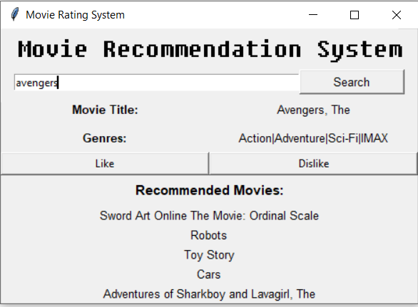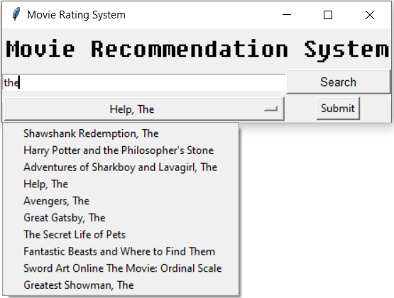I tried to use a List box to improve my selection process as suggested by Mr Ny but I found it very complicated to have my options in the list carry a variable. So instead I decided to use a search bar. The search bar has 3 different responses when the user enters something in. If the movie is entered matches only one movie that movie is displayed with the title and its genres, the user can then select Like or Dislike, this then generates recommendations. If the movie entered by the user matches multiple movies, a drop-down list appears with the possible movies the user meant. The user can then select a movie from the drop down and push the submit button, to then rate that movie. If the movie entered by the user does not match any movies a message appears letting the user know that is wasn’t found. To further improve this I’m going to calculate a percentage of how likely the user will like the movie recommended and display it. There is a current bug where if a user searches a movie, finds it, enters a movie which is not found, they cannot rate the movie which still appears selected as the movie variable will have changed.

|  |  |  |
| --- | --- | --- |
| Name | Question | Feedback |
| Mr Ny  (DTC Teacher) | - What do you think about the appearance/ functionality of the new GUI?  - What improvements could I make? | - The search bar makes it look much tidier and I like the dropdown of possible movies when there are multiple options.  - It would be great if the movie recommendations showed the genres next to them and a percentage the user will like it. |
| Addison Zhen  (DTC Student) | - What do you think about the appearance/ functionality of the new GUI?  - What improvements could I make? | - I like that the movie selected is displayed with the title and genres, it makes the GUI much more comprehensible.  - I don’t know, maybe displaying more information with the recommendations like genres and year. |

**Feedback Conclusion**

From this feedback I can see that the search bar is a massive improvement to the GUI and that my stakeholders really like the new layout GUI. To improve I’m going to change how the recommended movies are displayed by adding titles for the movie title and genres, and then also displaying each movies genre.

## **New GUI with Genres Displayed (25/09/19)**

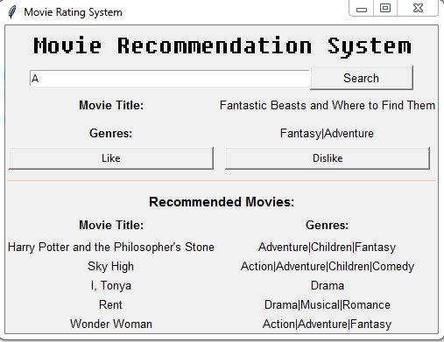I have changed the way the recommendations are displayed by adding in titles for the movie title and genres, as well as adding in the genres of the recommended movies in too. I have also used canvas to add in a line to separate things it was looking too clumped together and I think adding in the line give the GUI more dimension.

|  |  |  |
| --- | --- | --- |
| Name | Question | Feedback |
| Thomas Yang  (DTC Student) | - General Feedback  - Ideas for further development | - I like how I can put in a letter and a drop down comes up with all the movies containing that letter. I like the pixelated title and the line, I think it adds an artistic touch.  - Adding a percentage displayed based on the possibility index |
| Mr Ny  (DTC Teacher) | - General Feedback  - Ideas for further development | - Its definitely getting there but it needs something else.  - I would like to be able to select a genre and then get recommended movies based on the chosen genre. |

**Feedback Conclusion**

From this feedback I’m going to try add a genre selection so the user can choose a genre and then personalised recommendations. I can see that my stakeholders like the changes I’ve made to the GUI and don’t feel that much more development towards that is necessary.

## **New GUI with Genre Options 04/10/19)**

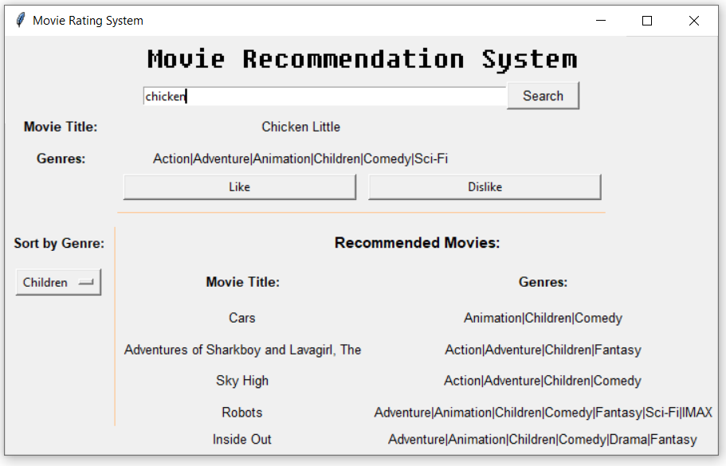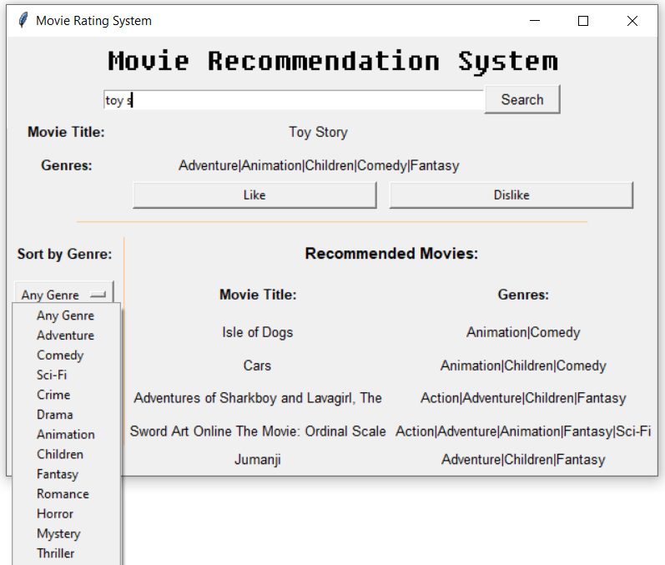I have been fiddling around with trying to enable the user to select a genre and then get recommendations from the genre selected. I have only got it to work partially so that the user can select a genre and the next time they rate a movie the recommendations they get will be of that chosen genre. I have not been able to get it to work in a way that the user selects a genre and then the movies recommended change to that genre. I also have an error where if the number of movies in my data base or recommended of a chosen genre is less than the number of movies previously displayed, the movies will not be covered up by the new recommendations and I have not been able to get them to disappear. If I were to develop this further I would fix the movie display error and try to improve the selected genre recommendations to change immediately when the genre is selected.

## **Fixed GUI Genre Option Movie Display (15/10/19)**

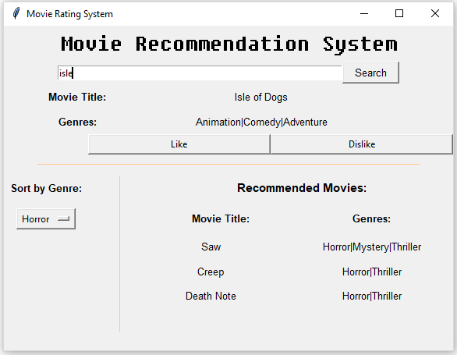I have fixed the error of the labels not disappearing when there are less than five recommendations.

# **References**

*Features*. (2019). Retrieved from Github: https://github.com/features

Rehkopf, M. (n.d.). *What is a kanban board?* Retrieved from Atlassian: https://www.atlassian.com/agile/kanban/boards